The Big Mac Index

The Big Mac index is a tool utilized by economists to evaluate whether a country's currency is undervalued or overvalued. The basic premise is that if i buy a Big Mac here, its cost should be equivalent elsewhere in the world. Using the data I got from Kaggle, I set out to answer one simple question: If i had to buy $100 worth of Big Macs, where would i get the most bang for my buck?

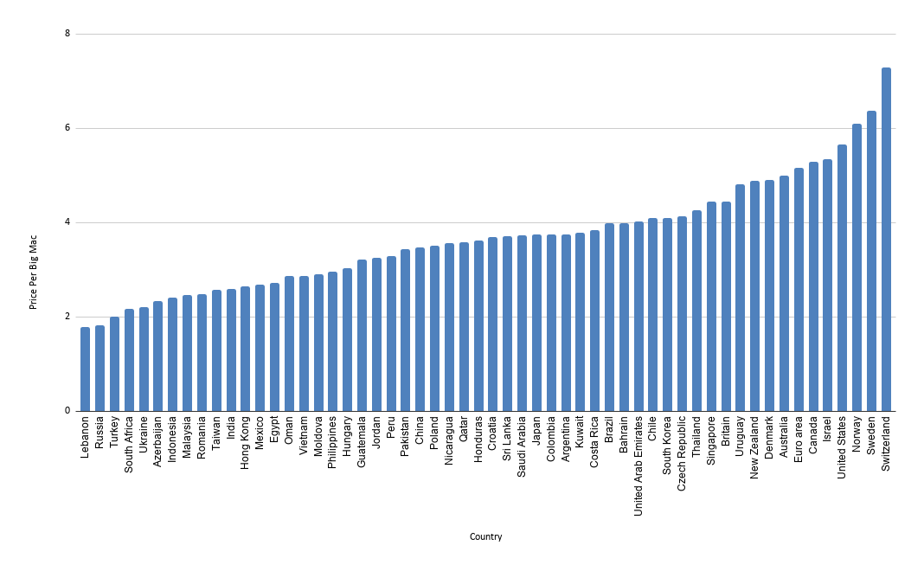

Using the above chart, the price per Big Mac per USD is highest in Switzerland at $7.29 and lowest in Lebanon at $1.77. Using the data, I made a chart using the price per big mac in each country converted into USD. If I bought $100 worth in Switzerland, I would end up with 13.72 Big Macs. If i bought them in Lebanon, i would end up with 56.5 Big Macs. My best course of action from this point forward is to purchase a plane ticket to Lebanon and to commit suicide in the most american way possible: eating big macs until i die. Thank you

Reflection: I found the sites for data super interesting and i had a hard time picking a topic to do this on. As a strong supporter of the Waffle House disaster scale, the big mac index spoke to me on a spiritual level and i couldnt say no. I wish i remembered everything i used to when it came to using excel. Google sheets was surprisingly easy to use and made it easy to understand and parse the data. Very cool project. Loved every minute of it